**Indira Gandhi National Widow Pension Scheme**

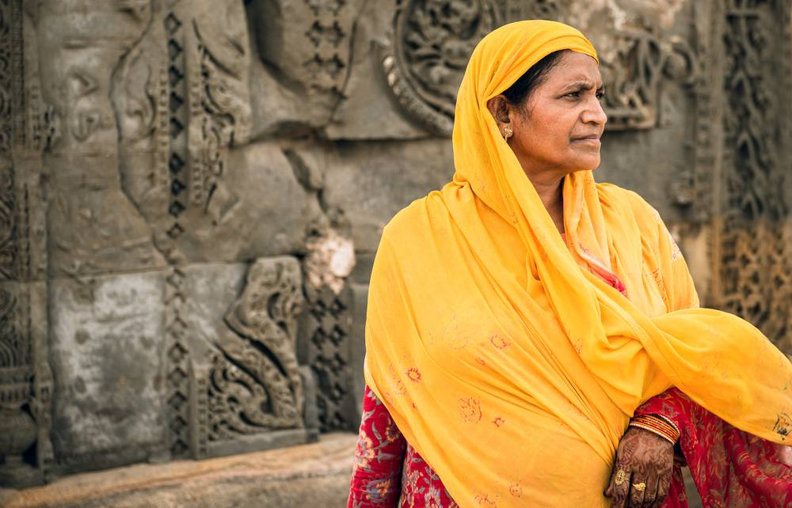

Indira Gandhi National Widow Pension Scheme (IGNWPS) is implemented by Ministry of Rural Development, Government of India. It is a non-contributory pension scheme to provide social security to widows of poor family (BPL) of the society.

**Benefits**

A pension of Rs.300/- per month is provided to Widows between 40 years and 79 years. For persons who are 80 years and above the pension is Rs.500/- per month.

**Documents**

* Death Certificate of husband – With the name of the surviving wife(widow).
* BPL Card.
* Age Proof - For age, the birth certificate or school certificate may be relied on. In their absence ration card and EPIC may be considered. If there is no valid document, any Medical Officer of any government hospital may be authorized to issue the age certificate Eligibility Criteria
* The applicant must be a widow in the age group of 40-79 years.
* The applicant should belong to a household living below the poverty line according to the criteria prescribed by the Govt. of India Exclusion
* In case of remarriage of widow
* Once the widow moves above poverty line

**How To Apply**

* One can download UMANG App or visit website <https://web.umang.gov.in/web_new/home>
* The citizen can login using mobile number and OTP.
* Once logged In, citizen can search for NSAP.
* Click on “Apply Online”
* Fill the basic details, choose the mode of payment of pension, upload photo and click on “Submit”.